
Executive Summary: Approach and Development Guidelines for IT Architecture
Office Of The CIO
Publish Date: June 20XX
Bank of Tokyo-Mitsubishi, Ltd.
1251 Avenue of the Americas
New York, New York
Telephone: 212.xxx.xxxx
E-mail: Kpwio@BTMNA.com

About This Document
This paper describes the approach, methodology, and procedures that BTM's IT department uses to develop an IT architecture.
Audience
BTM’s IT Senior Management and all staff who are involved in designing and implementing IT Architecture should read this paper.

© 20xx Bank of Tokyo-Mitsubishi, Ltd.
All rights reserved. No part of this publication may be reproduced, transmitted, transcribed, stored in a retrieval system, or translated into any language, in any form by any means, without the written permission of Bank of Tokyo-Mitsubishi, Ltd. The information contained in this document is confidential and proprietary.
xxxxxxxx
Location of Document:

Contents

Contents iii

Introduction 1

Past Problem: Lack of Standards or Strategy 1

The Traditional Approach to IT Strategy 1

Future Solution: Develop A New Framework 2

Benefits of Designing A Solid IT Architecture 2

Quantitative Contributions 2

Qualitative Contributions 2

Minimizing Costs 3

Architecture Defined 4

A Generally Accepted Concept of IT Architecture 4

Our View: Definition by Layers 4

Developing A Framework for IT Architecture 6

The Framework from Start To Finish 6

Prerequisites To Creating An IT Architecture 7

Business Strategy 7

IT Strategy 7

User Requirements 8

Phasing In A New IT Architecture 9

Phase 1: Architecture Strategy and Vision 9

Phase 2: Creating A Framework for Application Design 9

Phase 3: Designing The Architecture 10

Phase 4: Planning The Migration Process 10

Defining and Refining Architecture Requirements 11

Evaluating Current Business and IT Strategy 11

Evaluating Current Applications 12

Evaluating Current Data 12

Evaluating Current Technology 12

Evaluating Current IT Organization 12

Introduction
In today's changing business environment, management must have an IT architecture built on a robust framework with well-developed standards and procedures. These components must all work together to leverage and compliment business goals.
This paper discusses the process of establishing such an IT architecture. In this discussion, we examine the ‘building blocks’ of creating an IT architecture that aligns with business goals.
This paper:
- Defines the term ‘IT architecture ‘
- Describes the benefits of a well-designed IT architecture
- Describes the framework or structure on which we will build a new IT architecture
- Identifies the major phases and steps we will use in creating a new IT architecture
- Describes the tasks necessary to implement a new IT architecture

Past Problem: Lack of Standards or Strategy
In the past, the Bank of Tokyo-Mitsubishi's IT Group did not have a formal framework to set standards for the Bank's IT architecture. There was little in the way of an IT strategy which would forge a new IT architecture to handle future growth. Like many companies, BTM's approach to IT strategy and architecture was "best of breed." Users decided which system to implement, without considering architecture, support, or platform issues. They did this without following formalized rules. Unwritten standards make it difficult to maintain consistency of operations in a changing IT world.

The Traditional Approach to IT Strategy
Traditionally, IT is often considered a mere tool, and the IT strategy usually takes a subservient role to the business strategy. Business units take a two-pronged approach to IT. First, they establish their objectives and develop a strategy. Then they instruct the IT organization to find the technology that would adhere to the strategy. It’s no secret. This approach is doomed to fail.
New technology forces changes in the development of business models and strategies. New business models and requirements foster new forms of electronic banking. Therefore, the relationship between technology and business is interactive and dynamic, not one way and static. Organizations must consider business requirements as well as the current IT environment (Gained by conducting software and hardware inventory).

Future Solution: Develop A New Framework
In response to these and other concerns, BTM’s Chief Information Officer initiated the IT Architecture Project in September 2001. The IT Architecture Project examines the current state of BTM’s Information systems and creates a framework and standards for producing a new IT Architecture.

The IT Architecture Task Force
To implement a new architecture, BTM has established an IT Architecture Task Force. This group is composed of six BTM, IT Senior Managers who work with BTM business units to develop a comprehensive IT Strategy. The Task Force works independent of all other projects and convenes into discussion and policy-making forums.

Benefits of Designing A Solid IT Architecture
A robust IT architecture provides the following benefits to business:

Quantitative Contributions
- A more efficient IT operation
- Lower software development, support, and maintenance costs
- Better return on investment in existing IT infrastructure
- Reduced costs of IT ownership

Qualitative Contributions
- Improved interoperability and easier system and network management
- Higher reliability
- Improved ability to address critical enterprise-wide issues
- Reduced complexity of IT infrastructure, which reduces risk
- Increased flexibility to have options in developing, buying, or out-sourcing IT
- Improved methods for selecting faster, simpler, and cheaper solutions
One of the significant benefits of a good IT architecture is that it creates a structural blueprint, which is accessible to anyone who is required to know how IT delivers its promises to business units. Although some of the architecture may not have a visible or a noticeable impact on the business units, the architecture is designed to provide a foundation that sustains, enhances, and tolerates the range of daily IT activities.

Minimizing Costs
Establishing a clear structure or framework for information systems ensures that the architecture that we select allows for future growth. Once a comprehensive business strategy is defined, we will conduct an inventory to identify all operations, and platforms that all business units use. We will do this with an eye on minimizing the number of platforms along with any associated maintenance, and support costs. We will then be in a better position to decide which elements we keep in-house and which aspects we outsource.

Developing an IT Architecture Strategy
Moving forward, BTM will base its IT architecture strategy on assessing the current state of the enterprise, setting long-term objectives called ‘core values,' and establishing standards. Performing these tasks has one goal in mind: Aligning IT with the concerns of business.

Architecture Defined
The term "architecture" has been applied loosely in information technology. There is no single agreed upon definition. Additionally, the terms, "architecture" and "infrastructure" are used interchangeably and creates further confusion.

A Generally Accepted Concept of IT Architecture
In brief, "architecture" is a concept, whereas "infrastructure" refers to the actual physical systems that run applications. One of the more generally accepted definitions of "architecture," as it applies to IT, is as follows:
“One of the most common approaches to answering this question is to draw an
analogy between the architecture of buildings and the architecture of computing
systems. … Actually, in today's highly distributed computing environments, a
better analogy is with the discipline of Planning or Urban Design rather than
with Architecture as applied to individual buildings.”

- Keri E. Pearlson, “Managing and Using Information Systems: Strategic Approach”

While this analogy can be misleading, it serves to illustrate the basic concepts of "architecture." By this definition, architecture provides the philosophy and rationale behind the structural design for managing IT investment in a way that meets business requirements. This definition is not limited to defining IT architecture as separate building blocks. It takes into account that the separate blocks must work together as a unified whole.

Our View: Definition by Layers
We believe that IT architecture can be thought of as being comprised of various layers. These layers represent building blocks much like a physical structure or building but are not separate entities. They rely on input from each other.
Defining IT architecture in this fashion holds that architecture has three distinct layers:
- The Inventory of IT Architecture: This is the first layer or foundation. This layer is composed of the basic building blocks of IT Architecture, such as hardware, software, data, and communications links. This is the IT infrastructure- the actual physical components of the architecture.
- The Functional Use of Information Technology: This layer represents the functional use of information technology and has two parts: The baseline blueprint (the assessment of the IT components) and the ‘planned blueprint’ (the future IT designs).
- The Strategic Plans for the use of IT in the business: In this layer, business strategy is the last layer and specifies business goals.
The following diagram illustrates the Layers definition of architecture.
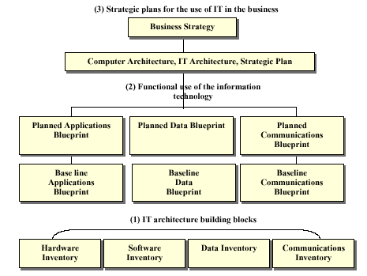

Developing A Framework for IT Architecture
When designing any type of system or process, it is often necessary to create a structure or a framework on which to build. The IT Architecture Framework presented here addresses the need for a standard method of developing an IT Architecture. A set of building blocks representing tasks comprises this framework. These tasks are linked together by the relationships they foster with one another.

The Framework from Start To Finish
BTM’s IT architecture strategy is comprised of four phases which progress from defining a vision of the new IT architecture to implementing that new architecture. The following diagram illustrates the high-level stages that BTM will use in this process.
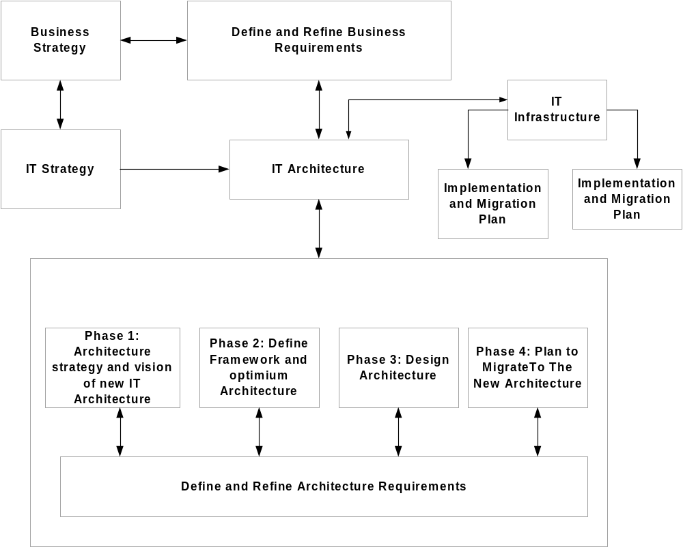
As illustrated in the diagram above, the phases or steps in developing an IT Architecture are dependent upon the following key inputs:
- A clear understanding of BTM’s core business strategy
- Well-defined business requirements
- An IT strategy that aligns with the business strategy

Prerequisites To Creating An IT Architecture

Business Strategy
Before we can begin to perform the steps that are necessary for creating a new IT architecture, we must identify the functionality of various business groups. We do this by taking an inventory of all applications and platforms that exist in each business unit with an eye towards minimizing the number of platforms. We hope to reduce personnel, maintenance and support costs. From this information, we can decide which applications and platforms we outsource and which we keep in-house.

IT Strategy
IT strategy holds the following place in BTM IT’s enterprise strategy:
- Management must develop Business, IT, and Operational strategies and ensure that each aligned with each other to form an enterprise strategy.
- Although the strategies are inter-linked, each has its own unique constraints and priorities, which senior management must consider.
- IT management is responsible for developing an IT strategy that ensures that IT core values are followed. Following such a framework benefits the overall systems environment.
- While business units are concerned with functional aspects and the operations units' primary focus is processing, IT must serve both entities with constraints imposed by infrastructure components. IT strategy, therefore, requires a clearer and methodical approach than the business and operations strategies currently have.
Aligning IT strategy with the strategies of business and operations is a difficult task. The rapid advancement of technological innovations and the shortened lifespan of the business/ operations model make such an alignment very difficult. Although, the so-called, “best of breed” approach seems to make sense for the rapid deployment of the IT strategy, given the best available solutions, it tends to create a systems environment that:
- Does not align with the core IT value, which IT management must adhere to
- Creates a dispersed systems environment, which is difficult to manage and prone to accidents and errors
- Requires a diverse resource base, which is costly and difficult to manage
- Leaves behind a complex systems environment, which is difficult to renovate
- Is vulnerable to the vendors’ health and threats
Upon careful consideration of these issues and challenges, BTM IT management decided to create the IT strategy framework.
The IT strategy framework contains the following ‘core values’:
- Provide a stable and reliable systems environment to the enterprise
- Deliver solutions aligned with the needs of business/operations
- Deliver systems and applications in a timely manner
- Optimize IT investments and lower the total cost of ownership
The IT strategy, based on these core values is:
- Develop standards and uniformity, which reduce the complexity and improve the management and control of data, technology, security, and other infrastructure components. This facilitates a stable and reliable systems environment
- Clarify and strengthen the alignment of the IT strategy with the business/operations strategies. This facilitates the development of a comprehensive enterprise strategy
- Improve the communication between the IT and business units
- Establish the skill sets, and knowledge management to increase the efficiency and promote high quality standards
- Provide “cost-benefit” and other quantifiable analysis for measuring achievable goals
- Meet the expectations of the business and operations units

Balanced Scorecard
In addition to these strategic measures, BTM HQA is implementing a Balanced Scorecard approach that measures and verifies the IT strategy along with its enterprise strategy. The Balanced Scorecard is designed to ensure that the IT strategy is delivering the value that was promised to the enterprise.

User Requirements
Following the methodology developed by the Business Alignment unit, we inventory each business unit’s requirements and then use this information to define the impact on the IT architecture.

Phasing In A New IT Architecture
Once we have identified the core BTM business strategy, developed an IT Strategy, and captured the requirements of business users, we can begin to perform the steps necessary to create a new IT Architecture.

Phase 1: Architecture Strategy and Vision
The first phase, Architecture Strategy and Vision, is concerned with understanding company business goals and strategies, understanding business requirements, developing a vision of the new architecture, and defining the way in which the new architecture will support business.
In this phase, we perform the following four tasks:
- Task 1: Establish a project organization: A core team of senior staff from business and IT management will define responsibilities and set priorities.
- Task 2: Create an initial master plan: The project organization will specify tasks, and set time frames for their completion.
- Task 3: Plan a strategy: The project team identifies relevant benchmarks and best practices from outside sources. This way, we can learn what procedures and technologies have worked for others and what mistakes we can avoid.
- Task 4: Develop a vision of the new IT architecture: The Project Team gathers a set of IT alternative IT architecture approaches. They evaluate each approach and identify the one that provides the highest level of benefit to the business. Then they gather cost, evaluate impact, and analyze the cost/benefit tradeoff.

Phase 2: Creating A Framework for Application Design
In Phase 2, we define standards and guidelines on how we design new applications, how we store data, and which protocols we need to implement that will allow applications to communicate.
In this phase, we perform the following three tasks:
- Examine industry trends and best practices to identify any changes in business architecture, any widespread adoption of specific technologies, and any external business practices which foster a competitive edge.
- Identify constraints such as how software packages might impact the new IT architecture, network bandwidth requirements, and platform sizing.
- Identify legal and regulatory requirements that impose any limitations or restrictions on the design, the deployment, or the management of information systems.

Phase 3: Designing The Architecture
Phase 3 seeks to define the logical view of how data flows from the various applications, databases, and multiple users throughout the enterprise. This is the logical topology.

Phase 4: Planning The Migration Process
Phase 4 is responsible for identifying a sequence of tasks that must division must perform to implement the new architecture.
There are three tasks involved in planning a migration process:
- Planning Migration and strategy: In this step, we organize a full range of work involved in the transition from the old IT architecture to the new IT architecture into many significant projects.
- Developing a Master Plan: The master plan then further reduces the significant projects into smaller, sub-projects where cost and time frames can be estimated more precisely. Costs are also estimated during this stage as well as cost/benefit analysis.
- Evaluating and validating: Here, we review our results by examining the:
- Expected cost/benefits vs. those achieved
- Expected reliability vs. those produced
- Expected functionality vs. those achieved

Defining and Refining Architecture Requirements
Developing an IT Architecture that is relevant and meets the needs of the core business depends upon an accurate assessment of current IT resources and business requirements. It is essential to develop a knowledge base consisting of all business processes and functions. We will also use this same fact-gathering process to identify any conflicting views held by management and other stakeholders.
The objectives of this process are:
- Gain a comprehensive understanding of business information and processing needs (current and planned), which the next architecture will be designed to support
- Identify and resolve issues regarding business requirements and IT solution
- Assess current IT capabilities and identify the gaps between existing IT capabilities and business needs.
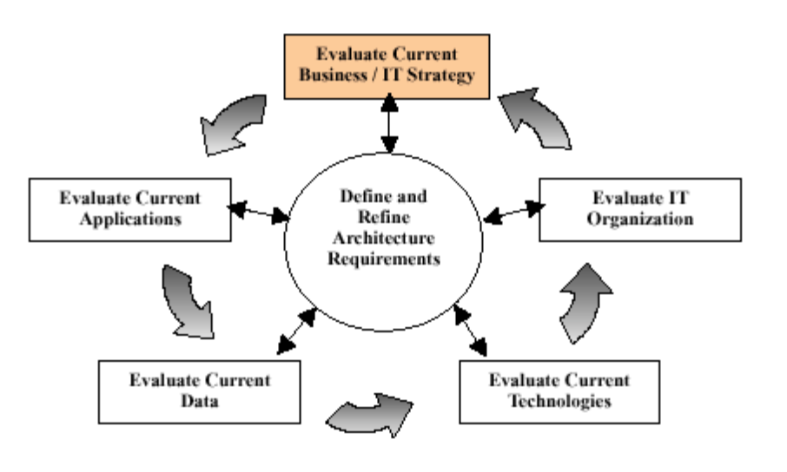The following diagram illustrates the continuous process of evaluating current resources, while at the same time defining and redefining business and IT strategies.

Evaluating Current Business and IT Strategy
First, we must evaluate the current business and IT strategy by gathering accurate and updated information regarding all current business processes. We will use this information to define the types of application services that we must deliver to user groups throughout the enterprise.

Evaluating Current Applications
Secondly, we must evaluate current applications by taking inventory of all IT applications, developing an application blueprint, and assessing whether the current applications are of high quality.

Evaluating Current Data
Thirdly, we study and model the structure of existing databases to understand the demands placed upon them. This entails examining the technology and processes currently in place that manages data across the enterprise for each major database.

Evaluating Current Technology
Next, we study the existing network infrastructure that connects user groups to system resources.

Evaluating Current IT Organization
And finally, we must evaluate the skills and capabilities of our IT staff. The question we must ask ourselves: How well does our IT skill set compliment the direction imposed by business units?

